Output Screenshot:

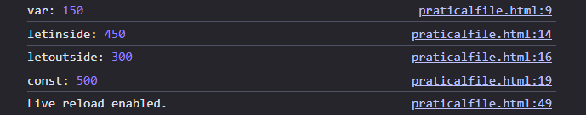
Output Screenshot:

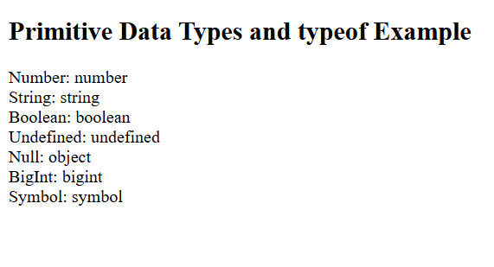
Output Screenshot:

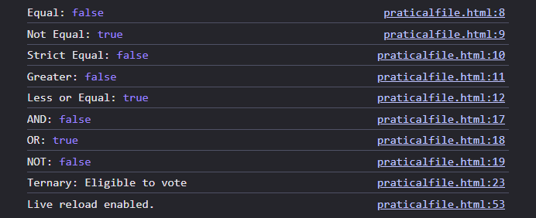
Output Screenshot:

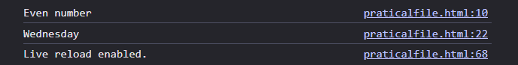
Output Screenshot:

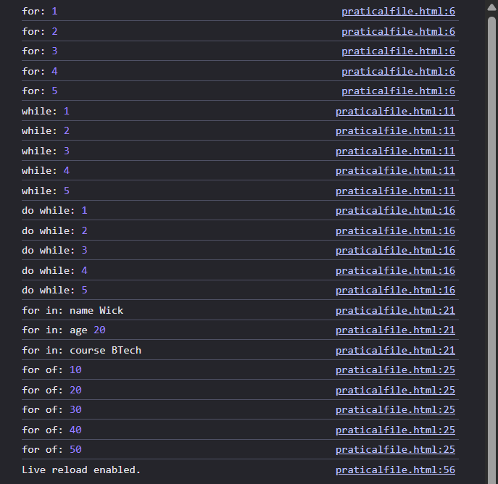
Output Screenshot:

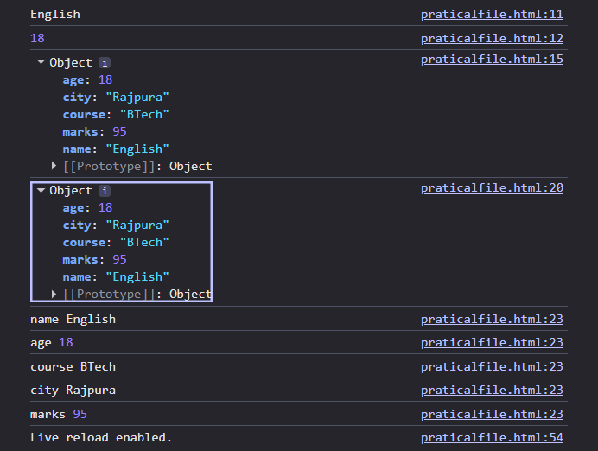
Output Screenshot:

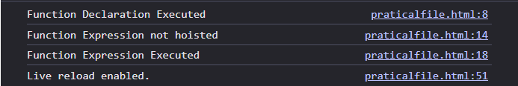
Output Screenshot:
